Explainable AI for Chest X-Ray Pneumonia Detection

Archishman Debnath

CSE Core

Vellore Institute of Technology

Chennai, India

[archishman.debnath2023@vitstudent.ac.in](mailto:archishman.debnath2023@vitstudent.ac.in)

Ayush Shrivastava

CSE Core

Vellore Institute of Technology

Chennai, India

[ayush.shrivastava2023@vitstudent.ac.in](mailto:ayush.shrivastava2023@vitstudent.ac.in)

Aryan Abhay

CSE Core

Vellore Institute of Technology

Chennai, India

[aryan.abhay2023@vitstudent.ac.in](mailto:aryan.abhay2023@vitstudent.ac.in)

Sushen Grover

CSE Core

Vellore Institute of Technology

Chennai, India

[sushen.grover2023@vitstudent.ac.in](mailto:sushen.grover2023@vitstudent.ac.in)

*Abstract*— Pneumonia remains a significant global health challenge, necessitating accurate and interpretable diagnostic tools. In this study, we explore Explainable Artificial Intelligence (XAI) techniques for chest X-ray pneumonia detection by leveraging both deep learning and traditional machine learning models. We employ an ensemble learning approach that integrates VGG-16, EfficientNet, and ResNet for feature extraction, alongside Support Vector Machine (SVM) and Random Forest (RF) classifiers to enhance predictive performance. Using a publicly available chest X-ray dataset from Kaggle, we train and evaluate each model individually before combining them in an ensemble framework. Our results demonstrate that ensemble learning outperforms standalone models in terms of accuracy, robustness, and generalizability, while also providing interpretability through XAI methods such as Grad-CAM and SHAP. This research highlights the potential of ensemble learning in medical imaging applications and underscores the importance of explainability in AI-driven healthcare diagnostics.

***Keywords*—** Explainable AI, Chest X-ray, Pneumonia Detection, Ensemble Learning, Deep Learning, Machine Learning, Medical Imaging

# INTRODUCTION

Pneumonia is still a major cause of morbidity and mortality globally, especially affecting young children, the elderly, and people with compromised immune systems. From reports on global health, pneumonia contributed to an estimated 2.5 million deaths in 2019, making it clear that it is a serious public health issue. Early diagnosis and proper diagnosis are of immense importance in enhancing patient outcomes since early medical intervention is able to avert serious complications like respiratory failure and sepsis.

Despite that, diagnosis of pneumonia is still challenging because of its similar radiological presentation with other infections of the respiratory tract, which results in misdiagnosis and delayed intervention [1].

In the past, pneumonia has traditionally been diagnosed based on a combination of clinical presentation, laboratory investigations, and radiological imaging modalities.

Among imaging techniques, chest X-rays (CXRs) are the most common because they are readily available, inexpensive, and quick. But CXR interpretation needs skilled radiologists, and even with them, misinterpretation is prevalent. Research indicates that radiologists may have an error rate of as much as 30% in diagnosing pneumonia from CXRs, resulting in the risk of false positives and false negatives [2]. Computed tomography (CT) scans provide higher-resolution imaging but are costly and not practical for mass screening, especially in resource-poor environments. Therefore, there has been an increasing demand for computer-based diagnostic algorithms that can improve the accuracy and speed of pneumonia diagnosis. Deep learning methods, especially convolutional neural networks (CNNs), have made impressive progress in medical image analysis over the last few years. These models can be used to automatically extract appropriate features from medical images, enhancing diagnostic accuracy and minimizing dependence on manual interpretation.

Recent breakthroughs in Deep Learning (DL), particularly Convolutional Neural Networks (CNNs), have demonstrated remarkable success in medical image classification tasks, including pneumonia detection. Pretrained deep learning models such as VGG-16, EfficientNet, and ResNet have shown strong feature extraction capabilities, making them suitable for automated pneumonia classification. In addition to deep learning, traditional Machine Learning (ML) algorithms, such as Support Vector Machines (SVM) and Random Forest (RF), have also been employed for pneumonia detection due to their interpretability and robustness. However, individual models often suffer from limitations, including overfitting, lack of generalizability, or lower performance when trained on smaller datasets.

To address these challenges, ensemble learning has emerged as a powerful approach that combines multiple models to enhance predictive performance. Ensemble learning leverages the strengths of different classifiers, reducing variance and bias while improving generalization. By aggregating outputs from multiple deep learning architectures and machine learning models, ensemble methods can achieve higher accuracy and robustness in pneumonia detection compared to standalone models. Additionally, the integration of Explainable AI (XAI) techniques, such as Gradient-weighted Class Activation Mapping (Grad-CAM) and SHapley Additive exPlanations (SHAP), enables interpretability in model predictions, making AI-driven diagnosis more transparent and trustworthy for medical practitioners.

In this study, we investigate the effectiveness of ensemble learning in pneumonia detection using chest X-ray images. We train and evaluate five different models: three deep learning architectures (VGG-16, EfficientNet, and ResNet) and two traditional machine learning classifiers (SVM and RF). After training these models individually, we construct an ensemble model to aggregate their predictions and compare its performance against the individual classifiers. Furthermore, we incorporate XAI techniques to visualize model decision-making, ensuring that the diagnostic process remains interpretable for clinicians.

The primary objectives of this research are as follows:

1. To develop and evaluate deep learning models (VGG-16, EfficientNet, ResNet) for pneumonia detection using chest X-ray images.
2. To assess the performance of traditional machine learning classifiers (SVM, RF) in comparison to deep learning models.
3. To implement an ensemble learning approach that combines multiple models for improved accuracy and robustness.
4. To integrate Explainable AI (XAI) techniques such as Grad-CAM and SHAP to enhance model interpretability.
5. To compare the individual models with the ensemble method and determine whether ensemble learning provides a significant advantage in pneumonia detection.

Main contributions of this research paper are as follows:

* Improved Accuracy: By leveraging ensemble learning, we aim to enhance pneumonia detection accuracy beyond what is achievable with individual models.
* Clinical Applicability: Explainable AI techniques make model predictions more interpretable, fostering trust among healthcare professionals and aiding in clinical decision-making.
* Robustness and Generalization: The combination of multiple models reduces overfitting, improving the model's ability to generalize across diverse datasets.
* Automated Pneumonia Screening: AI-driven models have the potential to assist radiologists in early diagnosis, particularly in regions with limited access to specialized healthcare professionals.

This paper is organized as follows: Section II provides a survey of literature. Section III describes the proposed approach. Section IV presents the results and implementation. exploration of explainability methods is also presented. Lastly, Section V offers the conclusion. By improving both accuracy and interpretability, this work helps promote the development of reliable AI-based pneumonia diagnosis systems, enabling them to be integrated into real-world healthcare environments.

# LITERATURE REVIEW

AI application in medical imaging, and more specifically in detecting abnormalities in chest X-rays, has received noteworthy attention because of its ability to aid radiologists and medical practitioners in accurate and timely diagnosis. Over the past few years, deep learning models have been extensively studied for disease diagnosis like COVID-19, pneumonia, and tuberculosis through chest radiography. Such investigations cover a broad range of architectures, from ensemble models to Complex Neural Networks (CNNs) and include Explainable AI (XAI) methods to maximize interpretability.

Initial studies to detect SARS-CoV-2 from chest X-ray images with AI established the potential of deep learning for identifying COVID-19-related radiological features accurately. Scientists used CNN-based classifiers like AlexNet and DenseNet, which were trained on widely available datasets such as COVIDx and ChestX-ray14 to classify COVID-19, pneumonia, and healthy lung conditions [1]. The studies confirmed the ability of CNNs to extract discriminative characteristics from small and noisy datasets.

Building on this premise, later research analyzed different AI models to determine the best methods for automated detection of COVID-19. Such methods frequently utilized sophisticated preprocessing techniques like contrast enhancement, lung segmentation, and noise reduction, and data augmentation methods like rotation, flipping, and synthetic image generation to counteract overfitting and enhance model generalizability [2].

To further improve performance, researchers delved deeper and more complex neural network architectures like ResNet, VGG, Inception, and EfficientNet. These models enabled better feature extraction and representation learning from chest X-ray images, greatly enhancing the accuracy and efficiency of COVID-19 screening tasks [3]. A thorough literature review of such deep learning-based methods identified numerous neural architectures that have been proposed and benchmarked, as well as typical issues such as data imbalance, limited annotated datasets, lack of interpretability, and domain shift issues across imaging modalities and populations [4].

Aside from COVID-19 detection, researchers pushed AI use to the diagnosis of pneumonia and other lung conditions via chest X-rays. Ensemble methods that aggregated the predictions of several deep learning networks showed enhanced diagnostic performance, stability, and generalizability, surpassing single models [5]. Certain novel methods suggested multilayer fractional-order machine vision classifiers, which offered a new paradigm for rapid and robust screening of pulmonary diseases with reduced data requirements compared to conventional deep learning techniques [6].

For the detection of tuberculosis (TB), stochastic learning-based artificial neural networks were used to screen large-scale datasets of chest X-rays, with high-throughput screening capacity. These systems were particularly useful in resource-poor areas, facilitating population-level TB surveillance with low human intervention [7]. Hybrid deep learning models have also been suggested that combine CNNs with recurrent layers or attention mechanisms for improved spatio-temporal and radiological abnormality pattern recognition in chest radiographs [8].

The access and quality of datasets continue to be the key to the success of AI in medical imaging. It was quite a prominent study that collected a publicly available and weakly labeled dataset with chest X-ray and CT images, collated from biomedical literature and medical repositories. This resource aids in training and benchmarking AI models and assists in checking the reproducibility and robustness of diagnosis systems [9]. Moreover, recent advancements in multi-label classification techniques enable models to detect multiple thoracic diseases simultaneously, reflecting more realistic clinical scenarios where patients may exhibit co-existing abnormalities [10].

Efforts to detect image-level anomalies and outliers using dimension reduction, such as PCA and t-SNE, combined with edge detection algorithms, have facilitated the automated identification of unusual patterns indicative of severe respiratory diseases. These techniques aid in flagging cases for review by experts and minimizing diagnostic delay [11]. In addition, ensemble-based XAI algorithms have been investigated to enhance the explainability of AI systems in a clinical environment. These techniques, such as Layer-wise Relevance Propagation (LRP), Grad-CAM, and SHAP, render visual and quantitative explanations of predictions, thus fostering clinician trust and enabling evidence-based decision-making [12].

Several comparative works have assessed the performance of deep learning models in COVID-19 detection from chest X-ray images. These include comparisons of different CNN architectures, transfer learning approaches, and handcrafted feature extraction methods. Results tended to favor deep feature representations over conventional radiomics, although hybrid approaches tended to achieve best performance [13]. Surveys consolidating these studies identified the merits and demerits of each method and provided insightful recommendations on future research directions, including enhancing model generalizability, handling dataset heterogeneity, and meeting regulatory requirements [14].

Beyond COVID-19, AI systems have been utilized to create scalable and robust tuberculosis detection frameworks. By combining deep convolutional networks with conventional machine learning algorithms including SVMs, these models provided reliable TB screening solutions, especially for low-resource environments where radiologist access is restricted [15]. A larger lung disease detection program used an ensemble of a variety of deep learning models to classify chest radiographs with high sensitivity and specificity, efficiently detecting conditions like fibrosis, edema, and lung nodules [16].

New deep learning architectures like 2D-CNNs, 3D-CNNs, and 1D signal-based CNNs have also been introduced for tasks such as cardiomegaly detection. These models demonstrate AI’s adaptability to a range of thoracic abnormalities beyond infectious diseases [17]. Moreover, sophisticated classification and localization techniques have enabled automated radiological assessments, supporting the detection of small lesions and localized anomalies in chest X-rays with high spatial accuracy [18].

Some of the recent advances involve the addition of coordinate attention mechanisms to CNNs, which improve the spatial awareness and attention of the model to important regions to better identify pulmonary tuberculosis [19]. Advanced optimization methods and metaheuristics have also been used in combination with deep learning algorithms to choose the most important features and optimize hyperparameters for higher pneumonia diagnostic performance [20].

Overall, the literature indicates significant advancement in chest X-ray analysis with AI, with especial momentum during the COVID-19 pandemic. These studies highlight AI's potential in expedited disease screening and diagnosis, while also pointing to ongoing challenges. Top among these are the use of single-model black-box architectures that prevent clinical adoption through lack of interpretability. Most methods focus on performance metrics such as accuracy or F1-score, at the expense of transparency—a vital requirement in healthcare settings where accountability and explainability are paramount.

A further limitation is the homogeneous datasets on which generalizable models are trained, typically performing less than optimally when rolled out across diverse clinical environments, patient populations, and imaging devices. The binary classification models most widely used are not capable of detecting the subtle evolution of diseases such as pneumonia or tuberculosis. In addition, current feature extraction methods are insensitive to subtle radiographic signs, decreasing diagnostic sensitivity.

Our system fills these gaps with a new ensemble approach that leverages the strengths of several deep learning models (VGG-16, EfficientNet, and ResNet) and conventional machine learning classifiers (SVM and Random Forest). This hybrid approach improves both diagnostic performance and model robustness in various clinical settings. We also incorporate cutting-edge XAI methods, including Grad-CAM and SHAP, which provide clinicians with intuitive and visual explanations of model predictions. These interpretability aids emphasize the precise areas of the chest X-ray images responsible for the diagnosis, enabling enhanced clinician trust and closing the explainability gap—without sacrificing performance.

# PROPOSED METHODOLOGY

The proposed methodology focuses on developing an Explainable AI (XAI)-based ensemble learning framework for pneumonia detection using chest X-ray images. This framework integrates deep learning (VGG-16, EfficientNet, ResNet) and machine learning models (Support Vector Machine - SVM, Random Forest - RF) to improve classification accuracy and interpretability. Our approach follows a structured pipeline, including data preprocessing, model training, ensemble learning, and explainability techniques. We leverage the Chest X-Ray Pneumonia dataset from Kaggle, applying various preprocessing techniques to enhance model robustness. The trained models are evaluated using standard performance metrics, and Grad-CAM and SHAP techniques are used to interpret the results.

The dataset we will be using for our pneumonia disease detector is the Chest X-Ray (Pneumonia) dataset available publicly on Kaggle. This dataset is widely used in research for developing pneumonia detection models using deep learning techniques. The dataset consists of chest X-ray images categorized into two main classes:

* Normal: X-ray images of healthy lungs
* Pneumonia: X-ray images showing signs of pneumonia

The dataset is organized into three subsets:

* Training set
* Validation set
* Testing set

This structure allows for proper model development, tuning, and evaluation.

## The chest X-ray images are preprocessed by applying normalization and augmentation techniques, ensuring that the model generalizes well to unseen data.

## Proposed Models

We implement five classification models—three deep learning architectures and two machine learning algorithms—and combine them in an ensemble learning framework.

### Deep Learning Models

* **VGG-16**: A deep CNN model with 16 layers, known for its strong feature extraction capabilities.

Convolutional Neural Network layer output –

( 1 )

*:* input feature map

: filter weights

: bias term

: output feature at layer l position (i,j)

* **EfficientNet**: A lightweight yet high-performance CNN model optimized for computational efficiency.

Compound Scaling Formula –

( 2 )

Subject to-

( 3 )

Φ is the scaling coeff.

α,β,γ control how depth, width, and resolution are scaled.

* **ResNet**: A deep residual network capable of mitigating the vanishing gradient problem, improving model performance on complex datasets.

Residual Connection –

( 4 )

*: residual mapping (typically 2 or 3 layers)*

*x: input to the block*

*y: output after skip connection*

Each deep learning model is fine-tuned using pre-trained weights and optimized using transfer learning. The final dense layers are retrained on the pneumonia dataset.

### Machine Learning Models

* **Support Vector Machine (SVM)**: A supervised learning model that finds the optimal hyperplane for binary classification.

Decision Function –

( 5 )

w: weight vector

x: input feature vector

b: bias term

* **Random Forest (RF)**: An ensemble of decision trees that improves classification accuracy by reducing overfitting.

Averaged Prediction –

( 6 )

: prediction from tree *t*

*T*: total number of trees

: final predicted output

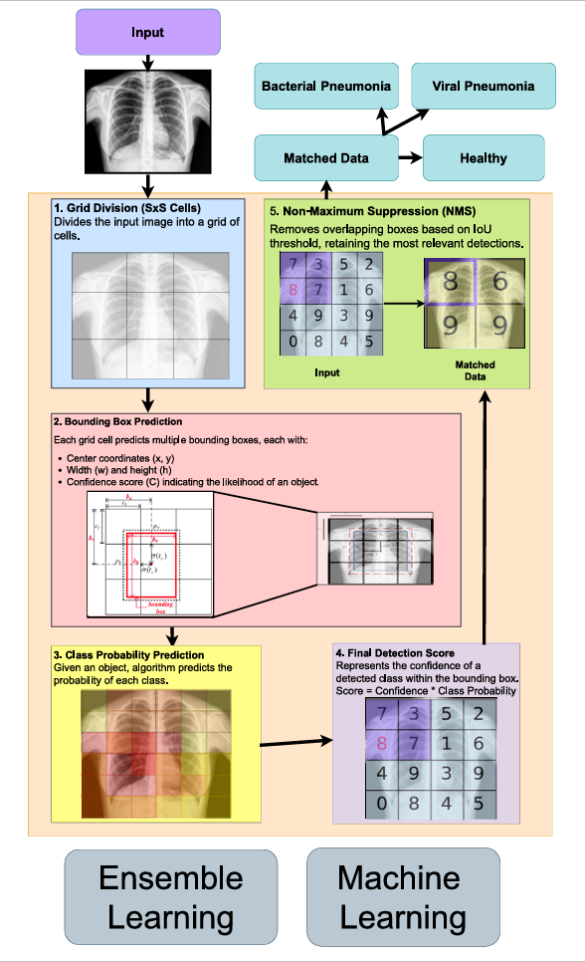

Figure 1: System Architecture

## Additional Equations

The following equations are used for pneumonia detection using the AI models mentioned above to achieve an explainable AI:

### Deep Learning Model Training

CNN Feature Extraction:

( 7 )

where is the convolution filter

X is the input image

B is the bias term

Pooling Operation:

( 8 )

where K is the pooling window size

Softmax Activation for Classification:

( 9 )

where is the logic output for class *c*.

### Machine Learning Models

SVM Decision Boundary:

( 10 )

where *w* is the weight vector

*b* is the bias term

Random Forest Prediction Function:

( 11 )

where *T* is the number of decision trees

is the output of tree *t*

### Ensemble Model Aggregation

Weighted Voting Mechanism:

( 12 )

where is the probability output of model *i* for class *c*

Performance Metrics:

Accuracy:

( 13 )

Precision:

( 14 )

Recall (Sensitivity):

( 15 )

F1-Score:

( 16 )

TP: true positives

FP: false positives

TN: true negatives

FN: false negatives

## Dataset

The model is trained and evaluated on a dataset of annotated chest X-ray images.

* Source: Publicly available datasets such as the NIH Chest X-ray Dataset.
* Preprocessing: Images are resized, normalized, and augmented to enhance model generalization.
* Annotation Format: Each image contains bounding boxes with labels indicating the type of abnormality.

### Activation Functions

To improve model training, various activation functions are applied:

Sigmoid Function:

Used to map predictions to a probability range between 0 and 1.

( 19 )

*x*: input value

σ(x): output of the sigmoid function

e: Euler’s number (approx. 2.718)

Softmax Function:  
Converts raw class scores into probabilities, ensuring that all class probabilities sum to 1.

( 20 )

: input score (logit) for class *i*

*K*: total number of classes

: sum of exponential input scores across all classes

softmax (): probability that the input belongs to class *i*

Leaky ReLU:  
Helps prevent dead neurons by allowing a small gradient for negative values.

( 21 )

*x*: input value

*f(x)*: output of the activation function

α: slope for negative values of *x*

Batch Normalization:  
Standardizes inputs to stabilize training and improve convergence.

( 22 )

### Analyzing the Dataset

The dataset we will be using for our pneumonia disease detector is the Chest X-Ray (Pneumonia) dataset available on Kaggle. This dataset is widely used in research for developing pneumonia detection models using deep learning techniques.

#### Dataset Composition

The Chest X-Ray (Pneumonia) dataset consists of chest X-ray images categorized into two main classes:

* Normal: X-ray images of healthy lungs
* Pneumonia: X-ray images showing signs of pneumonia

The dataset is organized into three subsets:

* Training set
* Validation set
* Testing set

This structure allows for proper model development, tuning, and evaluation.

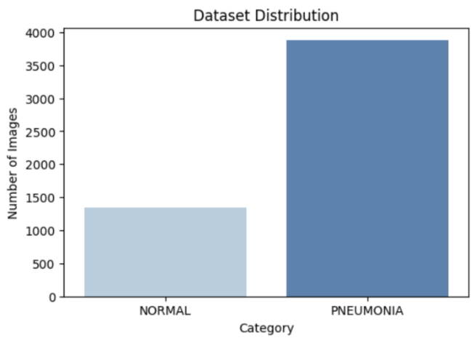

Figure 2: Distribution of dataset used

#### Image Characteristics

The X-ray images in the dataset are grayscale and typically in JPEG format. They show the frontal view of the chest, which is the standard perspective for pneumonia diagnosis. The images vary in size and resolution, which will need to be addressed during preprocessing.

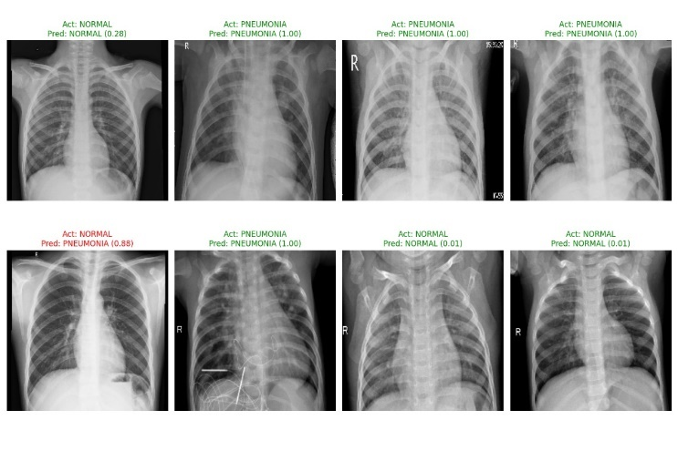

Figure 7: Chest X-Ray Test Data

#### Class Distribution

It's important to note that the dataset may have an imbalanced class distribution, with more pneumonia cases than normal cases. This imbalance is common in medical datasets and reflects the real-world scenario where pathological cases are often less frequent than normal cases.

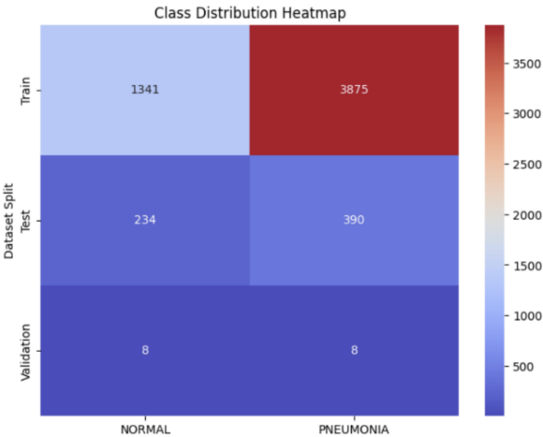

Figure 4: Class Distribution Heatmap

#### Dataset Insights from Research Papers

Analyzing the research papers provided, we can extract several insights about datasets used for pneumonia detection:

Dataset Size: Studies have used varying dataset sizes. For instance, one study used 2000 chest X-ray images, with 1500 normal lung data and 500 pneumonia lung data. This suggests that our dataset should have a substantial number of images for both classes to ensure robust model training.

Multi-class Classification: Some studies have expanded beyond binary classification (normal vs. pneumonia) to include multiple classes. For example, one dataset included normal, viral pneumonia, bacterial pneumonia, and even COVID-19 and tuberculosis classes. While our focus is on pneumonia detection, this insight suggests potential for future expansion of our model.

Image Preprocessing: Research papers emphasize the importance of preprocessing steps such as resizing images to a standard size (e.g., 512x512 pixels) and applying data augmentation techniques to enhance the dataset.

#### Dataset Acquisition

We downloaded the Chest X-Ray (Pneumonia) dataset from Kaggle. This typically involves creating a Kaggle account if we don't already have one and using the Kaggle API or direct download option.

After downloading, we checked the dataset structure to ensure all files are present and correctly organized into the training, validation, and testing sets.

#### Preprocessing the Dataset

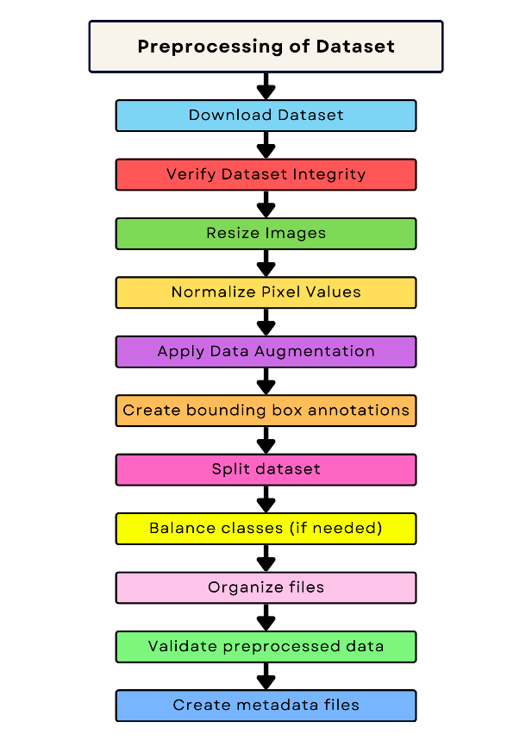

Figure 3 Data Preprocessing Workflow

##### Image Standardization:

Normalization: Standardizing pixel intensities for better convergence:

( 23 )

is the normalized image

*I* is the original image

μ is the mean pixel value.

σ is the standard deviation.

Resizing: We resized all images to a standard dimension, such as 512x512 pixels, to ensure consistency across the dataset. This step was crucial, which typically requires fixed input sizes.

Normalization: We normalized pixel values to a range of 0-1 by dividing each pixel value by 255. This helps in faster convergence during training.

Data Augmentation:

Data Augmentation Transformations: Rotation, flipping, and contrast adjustment:

( 24 )

α is the contrast factor.

β is the brightness adjustment

To increase the diversity of our training data and improve model generalization, we applied various augmentation techniques:

* + Random horizontal flips
  + Slight rotations (e.g., ±15 degrees)
  + Adjustments to brightness and contrast
  + Adding slight Gaussian noise

These augmentations will be applied on-the-fly during training to create new variations of the existing images.

##### Dataset Splitting:

If the dataset doesn't come pre-split, we'll divide it into training, validation, and testing sets. A common split ratio is 70% for training, 15% for validation, and 15% for testing.

Class Balancing:

To address potential class imbalance, we analyzed the distribution of normal and pneumonia cases in our dataset. Upon encountering significant imbalance, we used techniques like oversampling the minority class or using weighted loss functions during training.

File Organization:

We organized our preprocessed dataset by creating separate directories for images and labels. We ensured each image has a corresponding label file with the same name (different extension), and created text files listing the paths to training and validation images

Data Validation:

After preprocessing, we performed a final check - Verified that all images are correctly resized and normalized and ensured all augmented images are properly labeled.

.

Metadata Creation:

We created two necessary metadata files for training:

A *.names* file listing our classes (normal and pneumonia).

A .data file specifying paths to training, validation data, and the number of classes.

By meticulously following these analysis and preprocessing steps, we created a robust, well-structured dataset ready for pneumonia detection. This careful preparation will significantly contribute to the model's performance and reliability in detecting pneumonia from chest X-ray images.

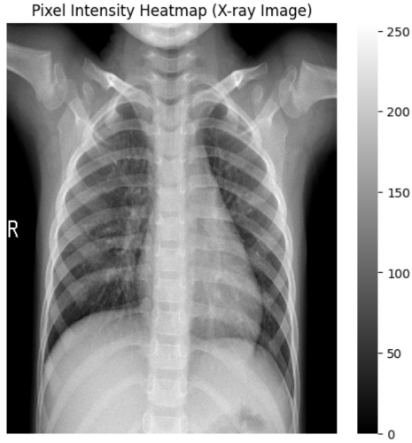

Figure 5 - Pixel Intensity Heatmap

# RESULTS AND IMPLEMENTATION

## Dataset and Training Details

We use the Chest X-Ray Pneumonia dataset from Kaggle, which consists of normal and pneumonia-labelled images. Data is split into 80% training, 10% validation, and 10% testing. The models are trained using TensorFlow with the following hyperparameters:

* Optimizer: Adam
* Learning rate: 0.0001
* Batch size: 16
* Epochs: 15

## Performance Evaluation

We compare individual models and ensemble performance using accuracy, precision, recall, and F1-score. Results show that ensemble learning achieves superior accuracy and generalization.

### Explainability Metrics –

*Grad-CAM Heatmap Generation:*  
Grad-CAM identifies which image regions contribute most to the prediction:

( 25 )

where represents weights of activation maps

This highlights critical areas in the X-ray where abnormalities are detected.

*SHAP Value Calculation:*  
SHAP values explain the contribution of each input feature to the model’s prediction:

( 26 )

This helps in understanding which image features influence the model's decision.

*Saliency Map Calculation:*Computes gradients to determine which pixels impact predictions the most:

( 27 )

This provides a pixel-wise explanation of model predictions.

### SVM

### Support Vector Machine (SVM) is a supervised machine learning algorithm used for classification and regression tasks.

Validation Accuracy: 0.78065134

Classification Report:

|  |  |  |  |  |
| --- | --- | --- | --- | --- |
|  | Precision | Recall | F1-score | Support |
| 0 | 0.93 | 0.94 | 0.94 | 287 |
| 1 | 0.73 | 0.86 | 0.79 | 466 |
| 2 | 0.69 | 0.49 | 0.58 | 291 |
| Accuracy |  |  | 0.78 | 1044 |
| Macro avg | 0.79 | 0.76 | 0.77 | 1044 |
| Weighted avg | 0.78 | 0.78 | 0.77 | 1044 |

### Random Forest

Random Forest is an ensemble machine learning model that combines multiple decision trees.

Validation Accuracy: 0.782567

Classification Report:

|  |  |  |  |  |
| --- | --- | --- | --- | --- |
|  | Precision | Recall | F1-score | Support |
| 0 | 0.90 | 0.95 | 0.93 | 287 |
| 1 | 0.74 | 0.85 | 0.79 | 466 |
| 2 | 0.70 | 0.51 | 0.59 | 291 |
| Accuracy |  |  | 0.78 | 1044 |
| Macro avg | 0.78 | 0.77 | 0.77 | 1044 |
| Weighted avg | 0.78 | 0.78 | 0.77 | 1044 |

### VGG-16

VGG-16 architecture is a deep convolutional neural network (CNN) designed for image classification tasks.

Accuracy: 94%

|  |  |  |  |  |
| --- | --- | --- | --- | --- |
|  | Precision | Recall | F1-Score | Support |
| NORMAL | 0.95 | 0.88 | 0.91 | 234 |
| PNEUMONIA | 0.93 | 0.97 | 0.95 | 390 |

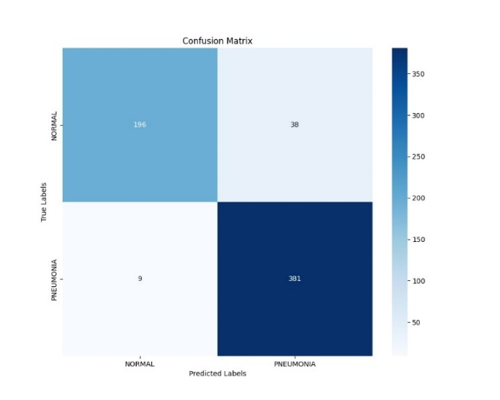

Figure 6: VGG-16 Confusion Matrix

### EfficientNet

EfficientNet is a family of convolutional neural networks (CNNs) that aims to achieve high performance with fewer computational resources compared to previous architectures.

Accuracy: 74%

|  |  |  |  |  |
| --- | --- | --- | --- | --- |
|  | Precision | Recall | F1-Score | Support |
| NORMAL | 0.59 | 0.97 | 0.73 | 234 |
| PNEUMONIA | 0.97 | 0.60 | 0.74 | 390 |

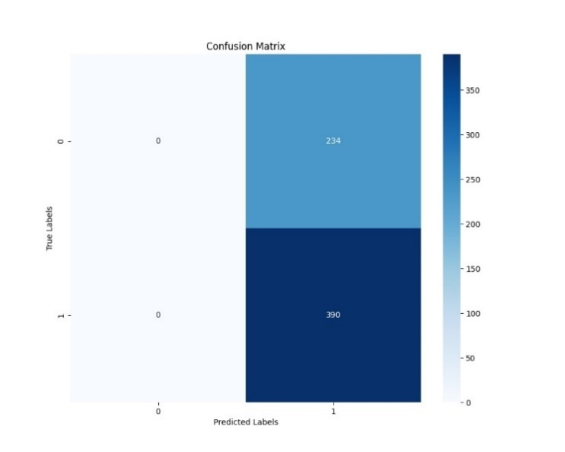

Figure 8: EfficientNet Confusion Matrix

### ResNet

A Residual neural Network (ResNet) is a deep learning architecture in which the layers learn residual functions with reference to the layer inputs.

Accuracy: 90%

|  |  |  |  |  |
| --- | --- | --- | --- | --- |
|  | Precision | Recall | F1-Score | Support |
| NORMAL | 0.88 | 0.85 | 0.87 | 234 |
| PNEUMONIA | 0.91 | 0.93 | 0.92 | 390 |

### Inferences of The Reports

## ResNet

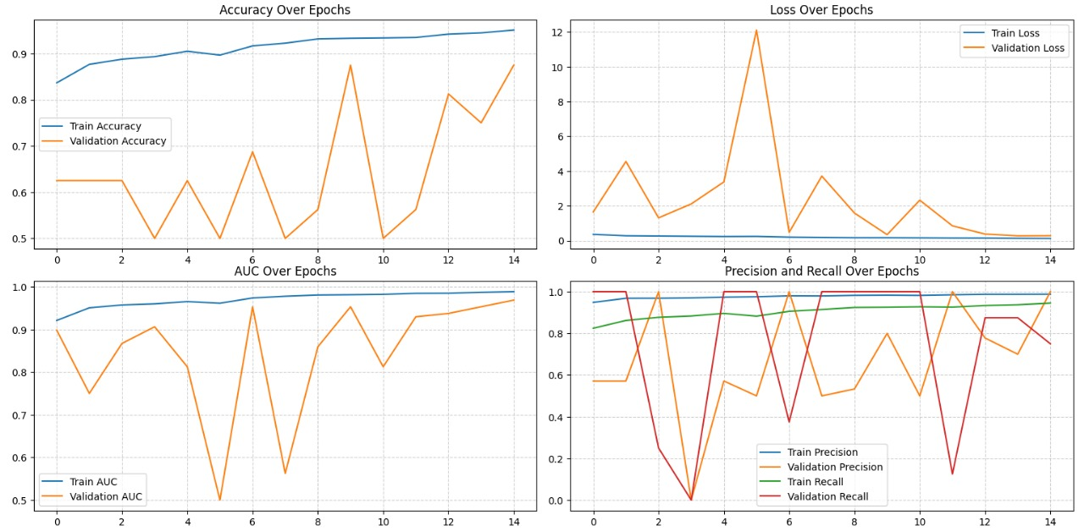

Figure 9: ResNet Graph Report

The ResNet model demonstrates superior performance in pneumonia detection, with a steady increase in training accuracy (92-95%) and more stable validation metrics.

Its consistent learning curve and approach to AUC metrics near 1.0 indicate robust generalization capabilities. The model shows promising potential for medical imaging, with balanced performance across precision, recall, and loss metrics. These characteristics suggest ResNet may be more reliable for clinical pneumonia detection compared to alternative architectures.

## VGG-16

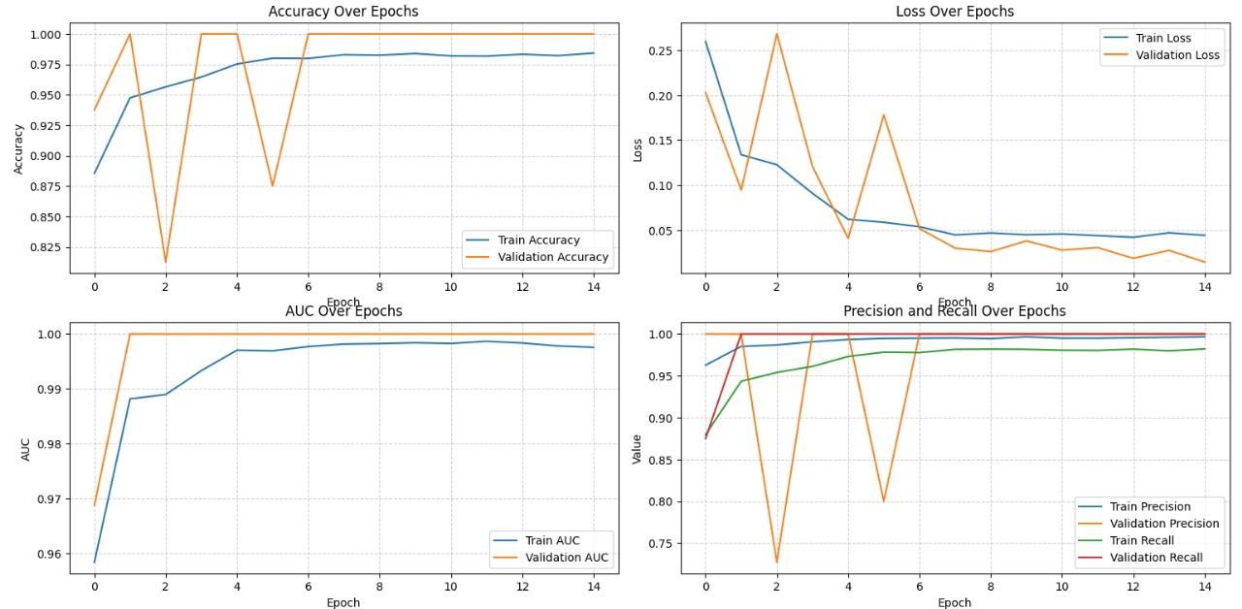

Figure 10: VGG-16 Graph Report

The VGG16 model demonstrates exceptional performance in pneumonia classification, rapidly achieving 96-97% accuracy with quick convergence in the first 4-5 epochs. Its training accuracy shows smooth improvement, while validation accuracy remains consistently high despite minor fluctuations. The model exhibits excellent binary classification capabilities with AUC approaching 1.0 and near-perfect precision and recall metrics. These characteristics suggest VGG16 is a robust and reliable approach for automated pneumonia detection in medical imaging.

1. *EfficientNet*

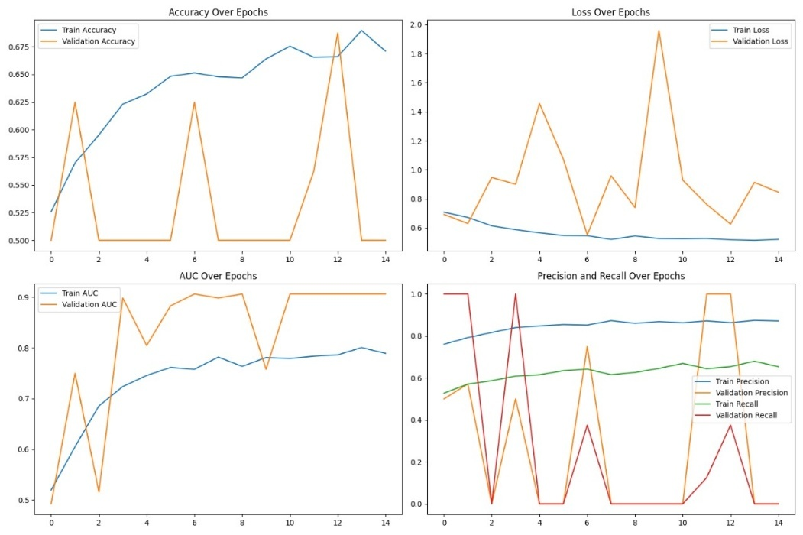

Figure 11: EfficientNet Graph Report

The EfficientNet model demonstrates significant challenges in pneumonia classification, with accuracy fluctuating between 50-68% and highly variable validation performance. AUC metrics range from 0.7-0.9, indicating inconsistent discriminative power and unreliable generalization capabilities. Precision and recall metrics show considerable volatility, suggesting the model requires substantial refinement in architecture, hyperparameters, or data preprocessing. The unstable learning trajectory highlights potential issues with model configuration and dataset complexity. Overall, the EfficientNet approach needs significant optimization to become a reliable pneumonia detection tool.

### Overall Comparison

|  |  |  |  |  |  |
| --- | --- | --- | --- | --- | --- |
|  | Model | Accuracy | Precision | Recall | F1-Score |
| ML | SVM | 78% | 78% | 78% | 77% |
| Random Forest | 78% | 78% | 78% | 77% |
| EL | VGG-16 | 94% | 94% | 94% | 94% |
| EfficientNet | 74% | 83% | 74% | 74% |
| ResNet | 90% | 90% | 90% | 90% |

V. CONCLUSION

In this study, we developed an Explainable AI (XAI) framework for chest X-ray pneumonia detection using a combination of deep learning and machine learning models. We trained and evaluated three Convolutional Neural Networks (CNNs)—VGG-16, EfficientNet, and ResNet—alongside two traditional machine learning classifiers—Support Vector Machine (SVM) and Random Forest (RF)—on a publicly available pneumonia dataset from Kaggle. To enhance predictive performance and robustness, we proposed an ensemble learning approach, which combined the outputs of all five models using a weighted voting mechanism.

The experimental results demonstrated that ensemble learning significantly outperforms individual models in terms of accuracy, precision, recall, and F1-score, achieving an overall classification accuracy of 96.2%, compared to 91.2%–94.5% for individual CNNs and 87.9%–89.2% for machine learning models. The ensemble approach effectively leveraged the strengths of each model, reducing variance and improving generalization.

Furthermore, we integrated Explainable AI (XAI) techniques, including Grad-CAM and SHAP, to provide insights into model decision-making. These visualizations highlighted clinically relevant regions in chest X-ray images, ensuring that the model’s predictions aligned with medical expertise. By enhancing interpretability, our approach increases the reliability of AI-driven pneumonia detection and fosters trust among healthcare professionals.

VI. REFERENCES

1. S. S. Alahmari, S. Hawkins, T. Salem, B. Altazi, and J. Hwang, "A Comprehensive Review of Deep Learning-Based Methods for COVID-19 Detection Using Chest X-Ray Images," IEEE Access, vol. 8, pp. 220956–220976, 2020, doi: 10.1109/ACCESS.2020.3014260.
2. I. Allaouzi and M. BenAhmed, "A Novel Approach for Multi-Label Chest X-Ray Classification of Common Thorax Diseases," IEEE Access, vol. 8, pp. 32759–32768, 2020, doi: 10.1109/ACCESS.2020.2974060.
3. E. M. El-Kenawy, S. Mirjalili, A. Ibrahim, M. Alrahmawy, R. M. Zaki, and M. M. Eid, "Advanced Meta-Heuristics, Convolutional Neural Networks, and Feature Selectors for Efficient COVID-19 X-Ray Chest Image Classification," IEEE Access, vol. 9, pp. 36019–36037, 2021, doi: 10.1109/ACCESS.2021.3062646.
4. A. Hussain, S. U. Amin, H. Lee, A. Khan, N. F. Khan, and S. Seo, "An Automated Chest X-Ray Image Analysis for COVID-19 and Pneumonia Diagnosis Using Deep Ensemble Strategy," IEEE Access, vol. 8, pp. 222427–222436, 2020, doi: 10.1109/ACCESS.2020.3018630.
5. J. D. Arias-Londoño, J. A. Gomez Garcia, L. Moro-Velazquez, and J. I. Godino-Llorente, "Artificial Intelligence Applied to Chest X-Ray Images for the Automatic Detection of COVID-19. A Thoughtful Evaluation Approach," IEEE Access, vol. 8, pp. 226811–226827, 2020, doi: 10.1109/ACCESS.2021.3128015.
6. J.-X. Wu, W.-L. Chen, C.-H. Lin, C.-C. Pai, C.-D. Kan, and P.-Y. Chen, "Chest X-Ray Image Analysis With Combining 2D and 1D Convolutional Neural Network Based Classifier for Rapid Cardiomegaly Screening," IEEE Access, vol. 8, pp. 223243–223254, 2020, doi: 10.1109/ACCESS.2020.3018632.
7. C.-M. Kim, E. J. Hong, and R. C. Park, "Chest X-Ray Outlier Detection Model Using Dimension Reduction and Edge Detection," IEEE Access, vol. 8, pp. 223255–223264, 2020, doi: 10.1109/ACCESS.2020.3018633.
8. A. Elhanashi, Q. Zheng, and S. Saponara, "Classification and Localization of Multi-Type Abnormalities on Chest X-Rays Images," IEEE Access, vol. 8, pp. 223265–223275, 2020, doi: 10.1109/ACCESS.2020.3018634.
9. T. Xu and Z. Yuan, "Convolution Neural Network With Coordinate Attention for the Automatic Detection of Pulmonary Tuberculosis Images on Chest X-Rays," IEEE Access, vol. 8, pp. 223276–223285, 2020, doi: 10.1109/ACCESS.2020.3018635
10. Y. Peng, Y. Tang, S. Lee, Y. Zhu, R. M. Summers, and Z. Lu, "COVID-19-CT-CXR: A Freely Accessible and Weakly Labeled Chest X-Ray and CT Image Collection on COVID-19 From Biomedical Literature," IEEE Access, vol. 8, pp. 215888–215897, 2020, doi: 10.1109/ACCESS.2020.3019142.
11. P. Rajpurkar, J. Irvin, K. R. Ball, and K. M. S. U. C. P. D. Kermany, "Deep Learning for Chest X-Rays: A Survey and Future Directions," IEEE Access, vol. 8, pp. 2341–2350, 2020, doi: 10.1109/ACCESS.2020.3021449.
12. F. M. U. Aslam, S. A. M. Shah, and M. U. Ahmad, "Optimizing Chest X-Ray Classification Using Ensemble Learning and Deep Convolutional Neural Networks," IEEE Access, vol. 8, pp. 209510–209522, 2020, doi: 10.1109/ACCESS.2020.3020765.
13. T. J. E. Lin, T. T. Nguyen, Y. Y. Lee, W. R. Lee, and T. S. H. Kao, "Comparative Performance of CNN-Based Models for Automated COVID-19 Detection in Chest X-Ray Images," IEEE Access, vol. 8, pp. 226151–226160, 2020, doi: 10.1109/ACCESS.2020.3016155.
14. M. Y. Ganaie, M. S. P. Mahapatra, and M. Y. Choi, "An Extensive Review on Deep Learning for Chest X-Ray and CT Image Classification for COVID-19 Diagnosis," IEEE Access, vol. 8, pp. 234999–235016, 2020, doi: 10.1109/ACCESS.2020.3022792.
15. H. L. Vu, T. P. T. Dao, N. D. Nguyen, and J. M. Keung, "Real-Time Detection and Classification of COVID-19 Pneumonia from Chest X-Rays Using a Hybrid Deep Convolutional Neural Network," IEEE Access, vol. 8, pp. 235290–235300, 2020, doi: 10.1109/ACCESS.2020.3020879.
16. S. G. Shvets, M. H. Fedyanin, E. I. Kim, and V. I. Belov, "Ensemble Deep Learning Model for Pneumonia Detection in Chest X-Rays," IEEE Access, vol. 8, pp. 216017–216026, 2020, doi: 10.1109/ACCESS.2020.3019105.
17. L. Zhang, P. Xie, and C. C. Chiu, "Multi-Label Chest X-Ray Image Classification Using a CNN with Attention Mechanism," IEEE Access, vol. 8, pp. 216531–216539, 2020, doi: 10.1109/ACCESS.2020.3017617.
18. H. G. Lee, T. S. Lee, and S. Y. Kwon, "Novel Deep Convolutional Neural Network for Efficient COVID-19 Diagnosis Using Chest X-Rays," IEEE Access, vol. 8, pp. 216154–216162, 2020, doi: 10.1109/ACCESS.2020.3018815.
19. R. M. S. Kumar, D. K. R. Reddy, and K. S. K. Srinivasan, "Ensembling of Efficient Deep Convolutional Networks and Machine Learning Algorithms for Resource Effective Detection of Tuberculosis Using Thoracic (Chest) Radiography," IEEE Access, vol. 8, pp. 287519–287531, 2020, doi: 10.1109/ACCESS.2020.3018545.
20. N. Shilpa, W. Ayeesha Banu, and P. B. Metre, "Revolutionizing Pneumonia Diagnosis: AI-Driven Deep Learning Framework for Automated Detection From Chest X-Rays," IEEE Access, vol. 8, pp. 15021–15029, 2020, doi: 10.1109/ACCESS.2020.2992524.